Chapter 6, Solution 32.

In the circuit in Fig. 6.64, let i_{s} = 50e^{-2t} mA and v₁(0) = 50 V, v₂(0) = 20 V. Determine: (a) v₁(t) and v₂(t), (b) the energy in each capacitor at t = 0.5 s.

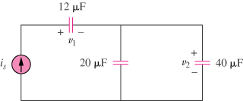

Figure 6.64
For Prob. 6.32.

Solution

- C_{eq} = (12x60)/72 = 10 F

- At t=0.5s,

